**Kaif Ikhlaq**

**SU 92 BSAIM S24-027**

**TASK : 4**

* 1

The code uses the Luhn algorithm to validate a card number by checking if the sum of the digits (with specific adjustments) is divisible by 10. It then prints whether the card is valid or invalid.

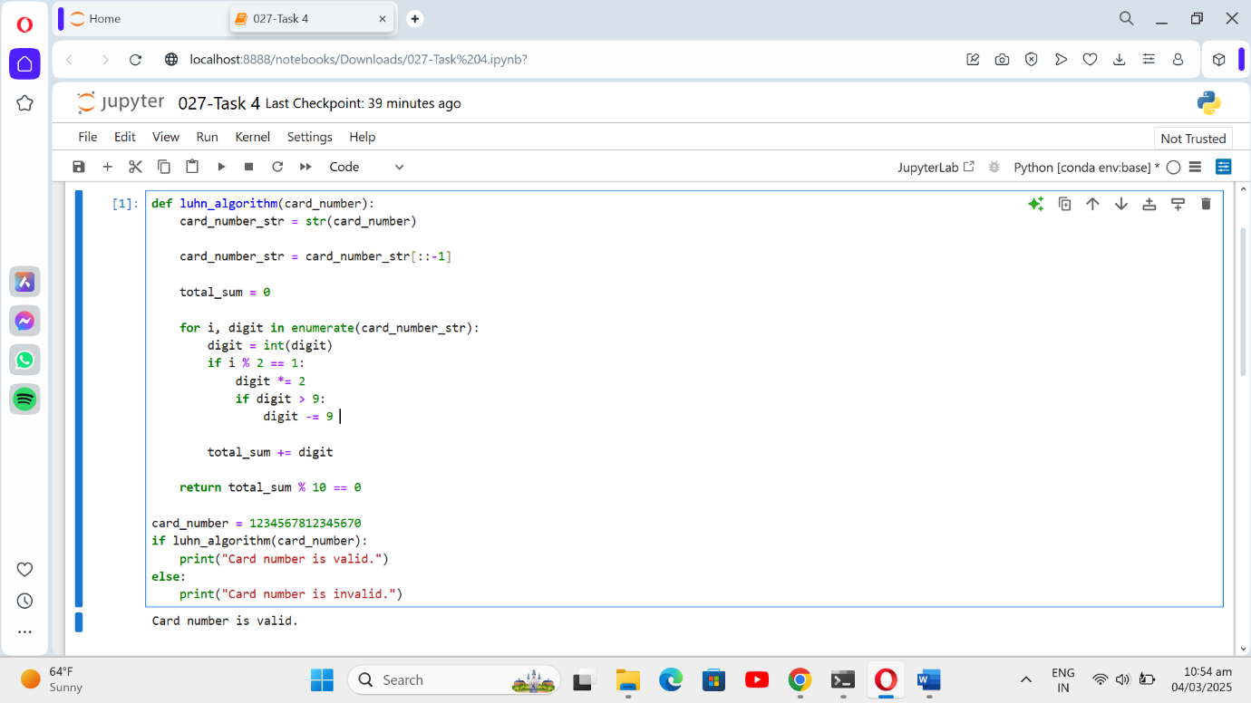

* 2

The code removes punctuation from the input string by iterating through each character and adding only non-punctuation characters to the result. It returns the cleaned string without punctuation.

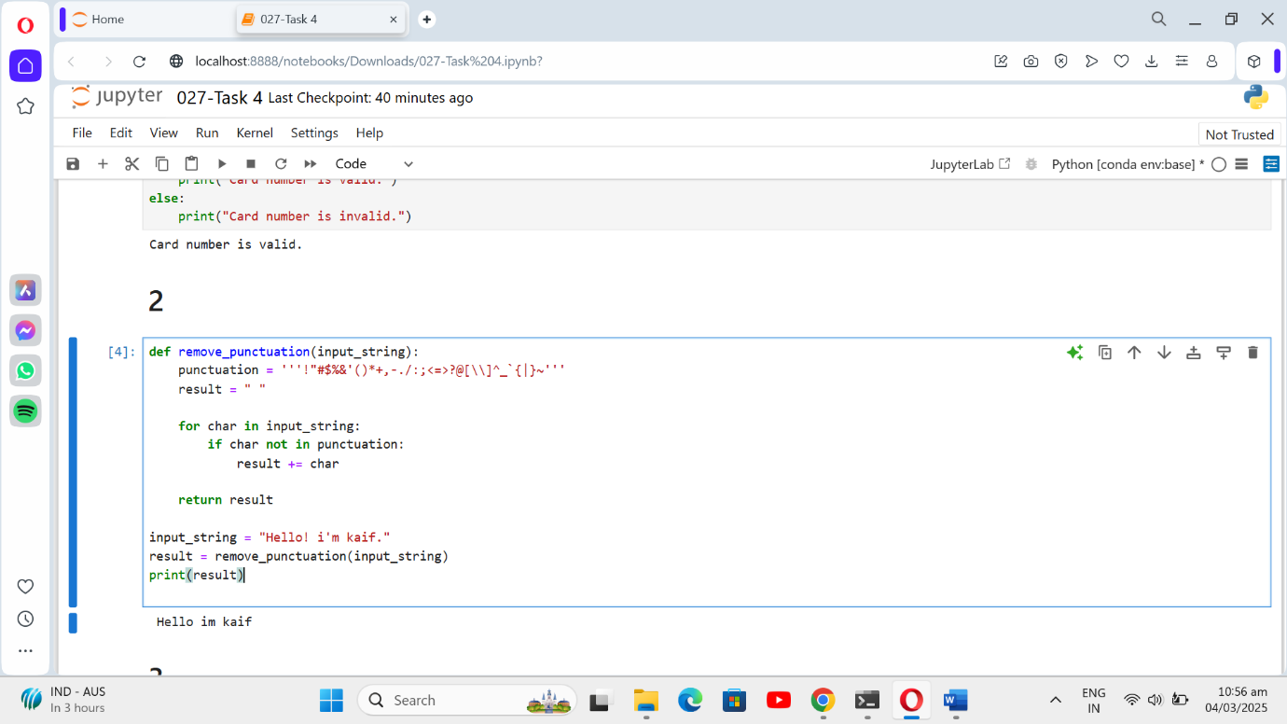

* 3

The code splits a sentence into words, sorts them alphabetically, and then joins them back into a sorted sentence. It returns the sorted sentence.

